Assignment 2: MathApp

COM577

Introduction 2

Question 1: Socket-based Solution 3

Client 3

Iterative Server 4

Concurrent Server 4

Testing and Evaluation 5

Question 2: HTTP-based Solution 6

Server 6

Testing 6

Client 6

Testing 6

# Introduction

This assignment is concerned with the development of several types of client-server system. For both the client and server, generic start-points are used for convenience, the server starting point asks the user which type of server to start: iterative, concurrent or HTTP. Likewise, the client starting point asks the user do they want to start a socket client or an HTTP client. The overall architecture is shown in the following diagram.

This architecture enables all the common code to be shared across the different clients and servers. The project structure across all client and server types implemented in this assignment is given below.

────mathapp

│ Client.java

│ Server.java

│

├───common

│ ClientBase.java

│ ServerBase.java

│ Colors.java

│ Constants.java

│ Logger.java

│ MathService.java

│ Params.java

│ Response.java

│ ResponseType.java

│

├───http

│ ├───client

│ │ HttpClient.java

│ │

│ └───server

│ HTTPServer.java

│

└───socket

│ IOSocket.java

│

├───client

│ SocketClient.java

│

└───server

│ Request.java

│ ServerConnection.java

│ ServerConnectionLog.java

│

├───concurrent

│ ConcurrentServer.java

│ ServerThread.java

│ ThreadManager.java

│

└───iterative

IterativeServer.java

On the client side, the assignment requirement to *“close the communication with the server after receiving one result”* has been interpreted as a user option so that should the user wish to perform several calculations before closing the client; then they can. If only one calculation is needed then the user can choose to close the client at that point. The way in which the user expresses the calculation they wish to have performed has not been specified in the requirements of the assignment and so an intuitive scheme has been adopted. The protocol for conveying the calculation between client and server follows the precise specification given in the assignment requirements e.g. +:6.7:3.2 .

With reference to tree structure above, appendix A contains a full listing of all classes in the mathapp root and common packages. Appendix B contains listings for the socket solution with appendix B.1 containing listings for the iterative server and B.2 containing listings for the concurrent server. Appendix B.3 contains the socket-based client which is shared between both iterative and concurrent servers. Appendix C contains source code for the HTTP server and client.

# Question 1: Socket-based Solution

In the following sections reference is made to “IOSocket”; this is a class that wraps a Socket and provides functionality to send and receive strings of text.

## Client

When the client starts, it instantiates a new IOSocket using a port number in common with the server it wishes to connect to. When the server accepts the connection, initially a confirmation of connection is received from the server. The client manages dialog with the user to obtain the maths calculation details, it builds a Params object which contains the maths calculation required and sends a stringified version of the calculation to the server via the socket.

A significant amount of validation of the user input takes place in the client, this is achieved through the getValidInput() and getYesNo() methods inherited from ClientBase.

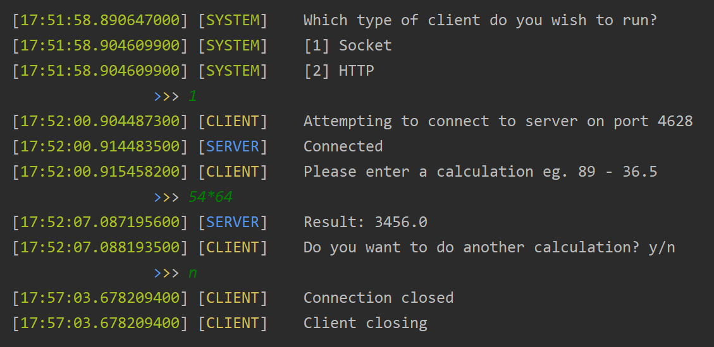The client waits for the calculation result to be returned and then displays this on the console for the user. At this point the user is prompted if they would like to perform another calculation and if not, the connection is closed and the client closes.

This client is used to connect to both the iterative and concurrent servers. The socket client’s source code is given in appendix B.3.

## Iterative Server

The iterative server (appendix B.1) handles both connection requests and transactions from a client in a simple manner which is depicted in the UML sequence diagram below.

When the server starts, it establishes a ServerSocket bound to a port and listens for an incoming client connection. When a client connects; the server sends an initial connection confirmation message to the client and then the client can make maths requests to server. The server makes use of the MathService class to perform the necessary calculations and return the results. During this period no further connections are accepted. When the client disconnects then the server goes back to listening for another incoming client connection. If two or more clients attempt to connect, the ServerSocket handles the queue of requests (up to 50 by default). When the current client disconnects, the next client connection request on the socket is accepted. This makes the iterative server a bottleneck if there are many clients requesting to connect and therefore limits its value.

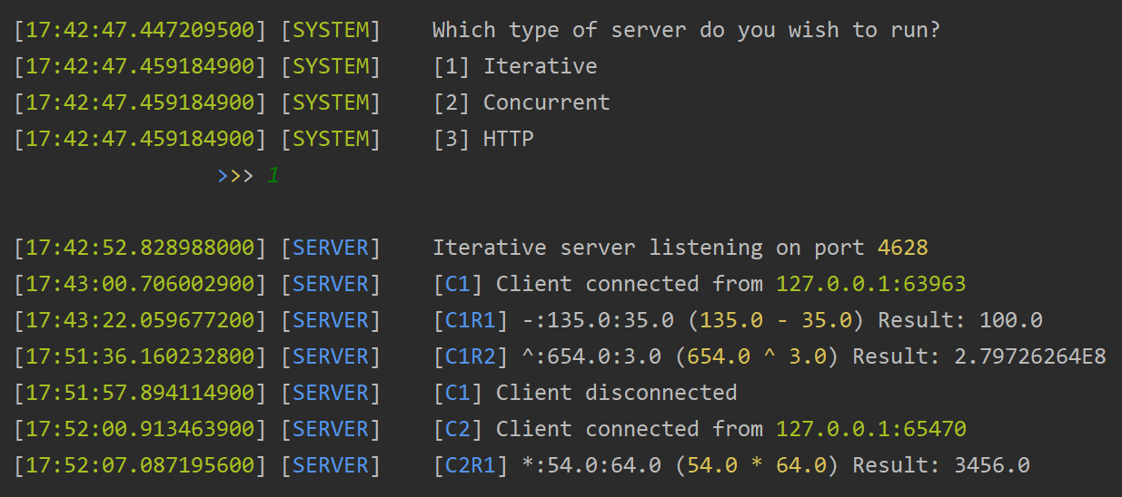The screenshot on the left depicts two clients sequentially connecting to the same iterative server, the first client can be seen making two calculation requests, with the second client only making one.

## Concurrent Server

The concurrent server gets arounds the limitations of the iterative server by delegating responsibility for servicing a client’s needs to a dedicated child server thread (ServerThread class). So, when the concurrent server starts up, it dedicates itself to listening for client connection requests on the ServerSocket. When a new client connection is received, the concurrent server spins up a new ServerThread instance to handle that client’s requests. The concurrent server then immediately goes back to listening for new connections.

The UML sequence diagram below depicts the interaction sequence for a client to connect to the concurrent server.

The ServerThread is responsible for all communication with the client. It sends a connection confirmation, receives the data from client, calls the MathService and returns the calculation result back to the client. When a client disconnects, the thread interrupts itself, causing it to terminate.

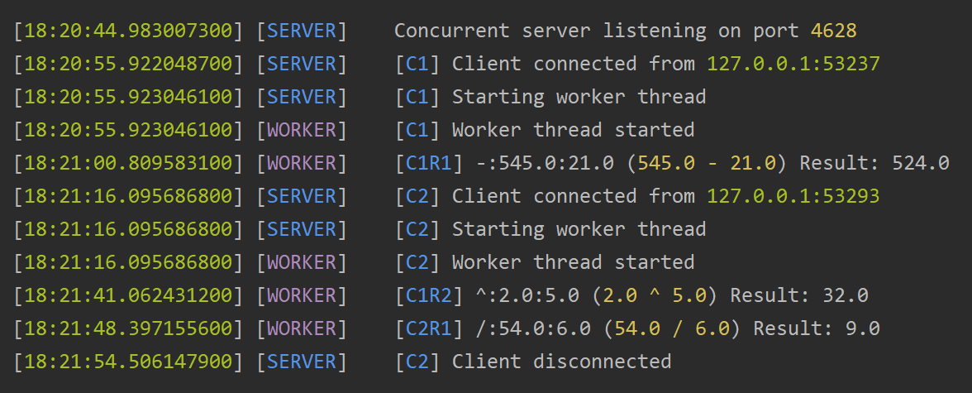The screenshot on the left depicts two clients connecting to the server. Separate worker threads are created to service each individual client and the screen shows the two clients making concurrent requests.

## Testing and Evaluation

# Question 2: HTTP-based Solution

## Server

### Testing

## Client

### Testing